Alternative Commands
Command | What It Does
npx cap sync | Copy + Update + Install (all-in-one)
npx cap copy | Just copy web assets (faster)
npx cap update | Just update plugins
npx cap sync android | Sync only Android
npx cap sync ios | Sync only iOS

Pro Tip: Live Reload
For faster development, you can use:
# Start a local web server
npx cap run android --livereload --external

# or for iOS
npx cap run ios --livereload –external
This watches your www/ folder and automatically syncs changes to your devi
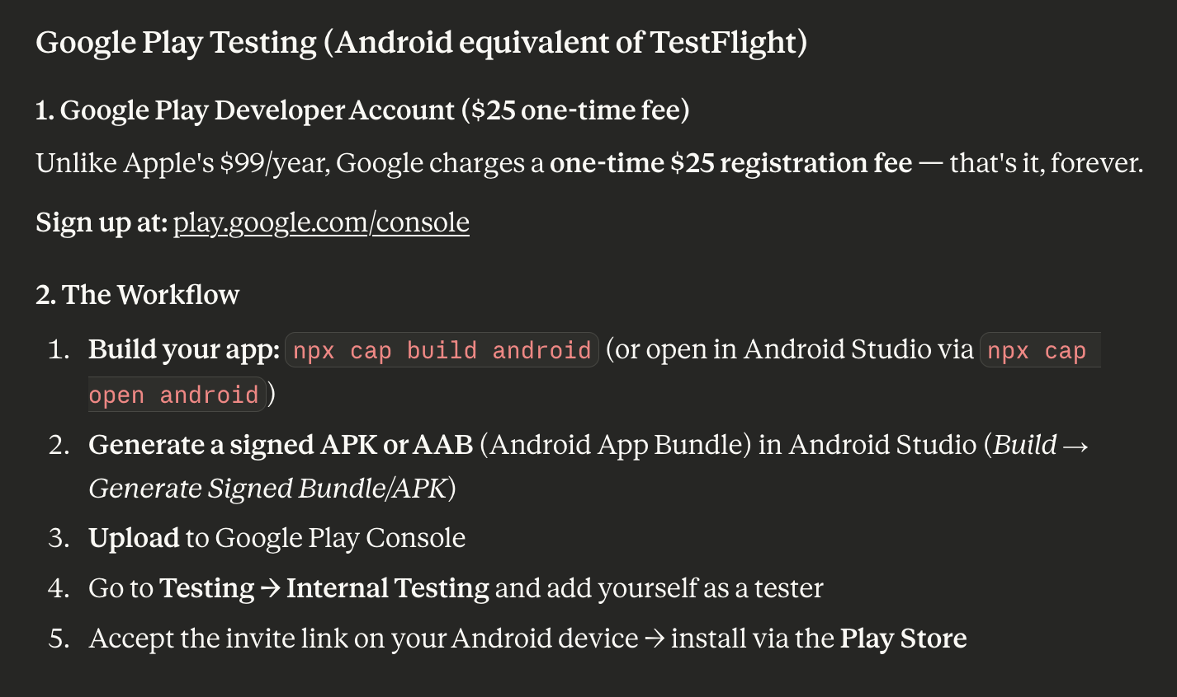

In Android, top command bar: Build→GenerateApp Bundles or APKs→Generate APKs
NOTE: View the build process in the lower right corner of Android Studio. When done, hit the ‘Locate’ button to find the new build. Upload it to the Ktesa Google Drive

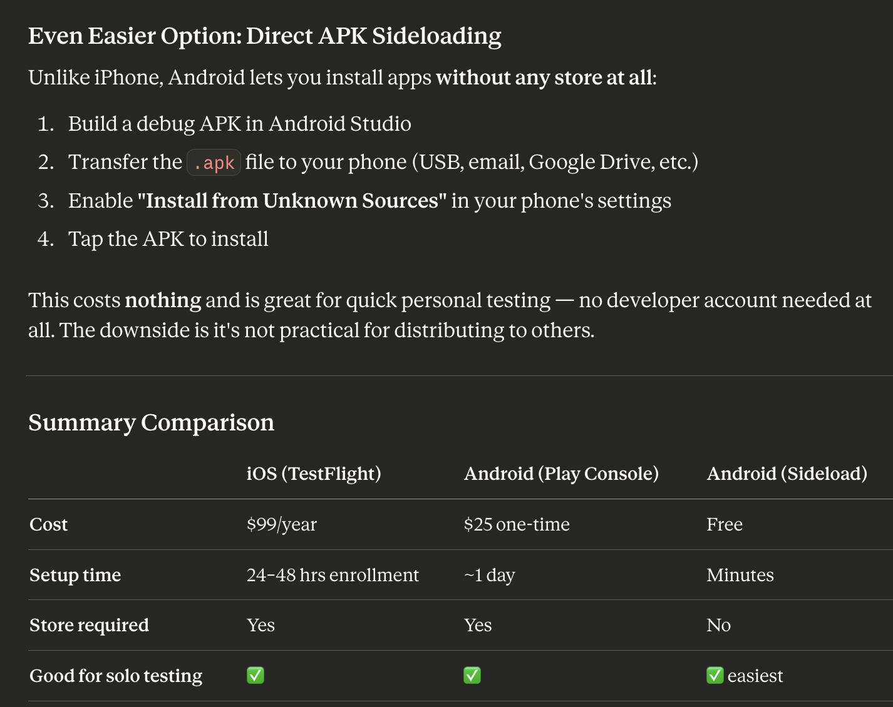

Distributing to Android
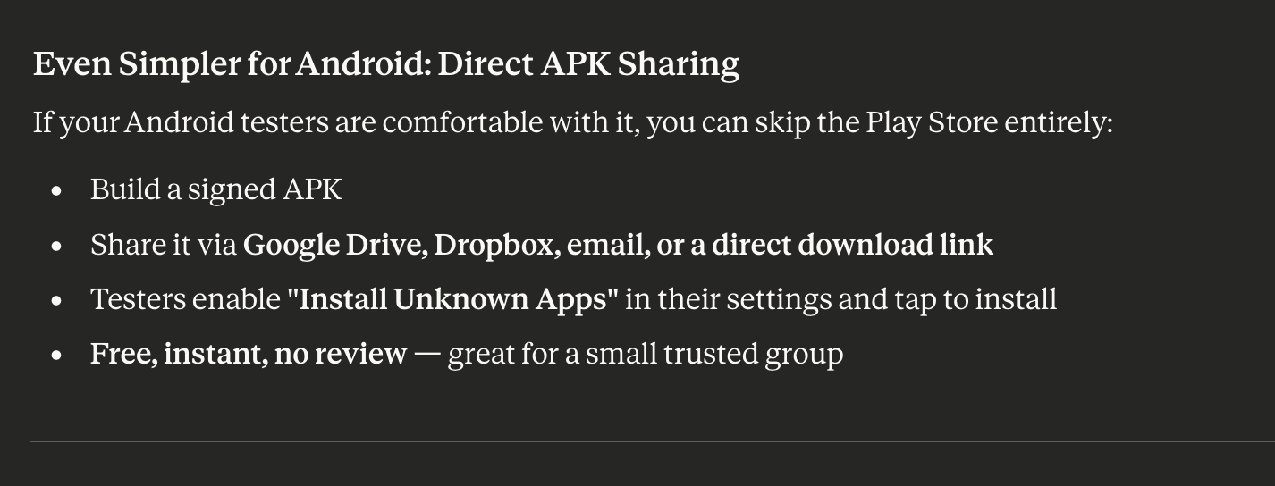

Continued...

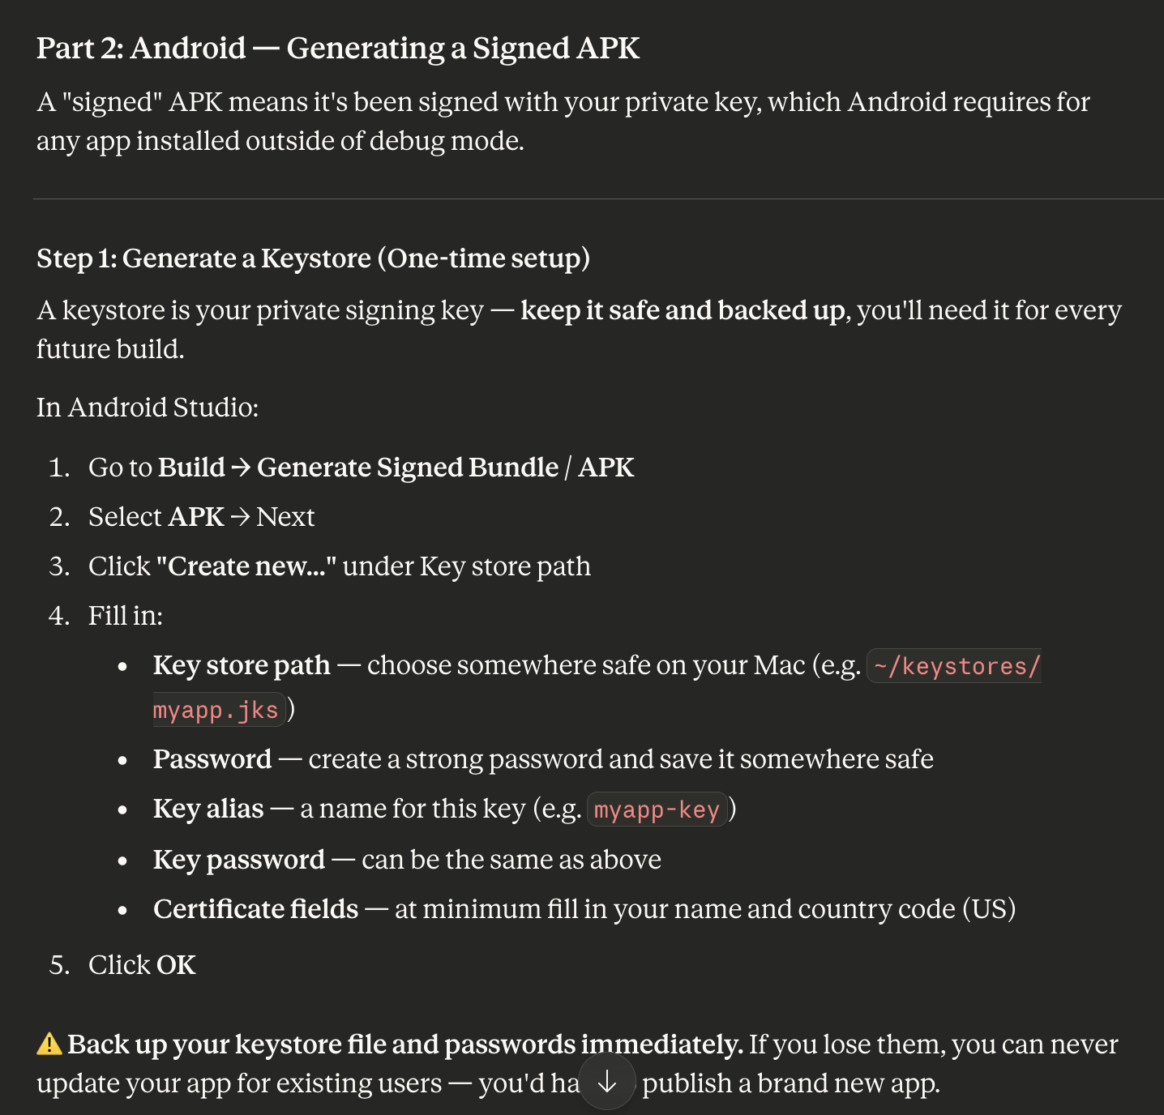

NOTE: This process (Key store path) didn’t seem to be required ...

Continued...

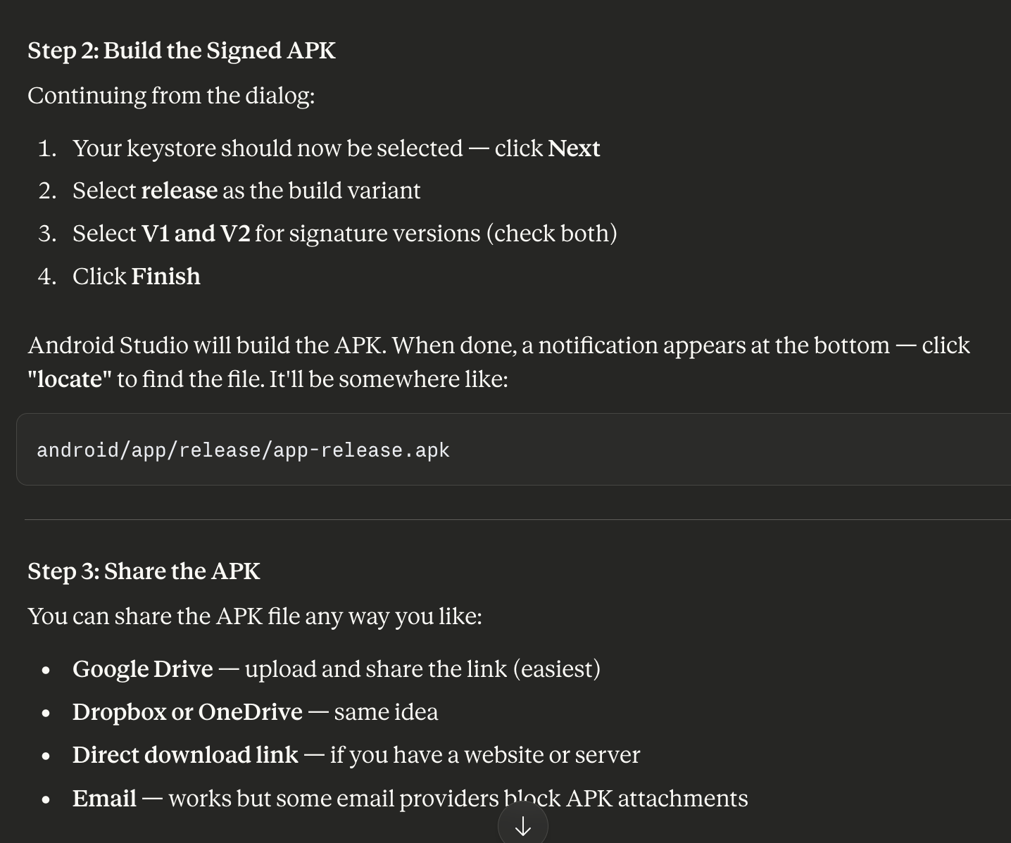

The Android Studio ‘Project Dropdown’ (top left bar) needs to show ‘Android’ NOT ‘ktesa_app’! Otherise, there is a ‘manual’ backup process:

To build the signed apk [manually]
cd android
./gradlew assembleRelease

NOTE: More caching problems:
- If the release is ‘unsigned’, ‘touch’ the android/app/build.gradle file and rerun (android/) ./gradlew assembleRelease

apk is located in android/app/build/outputs/apk/release/

Firebase: Firebase Console; search for “App Distribution”; drag and drop builds; add testers as needed.

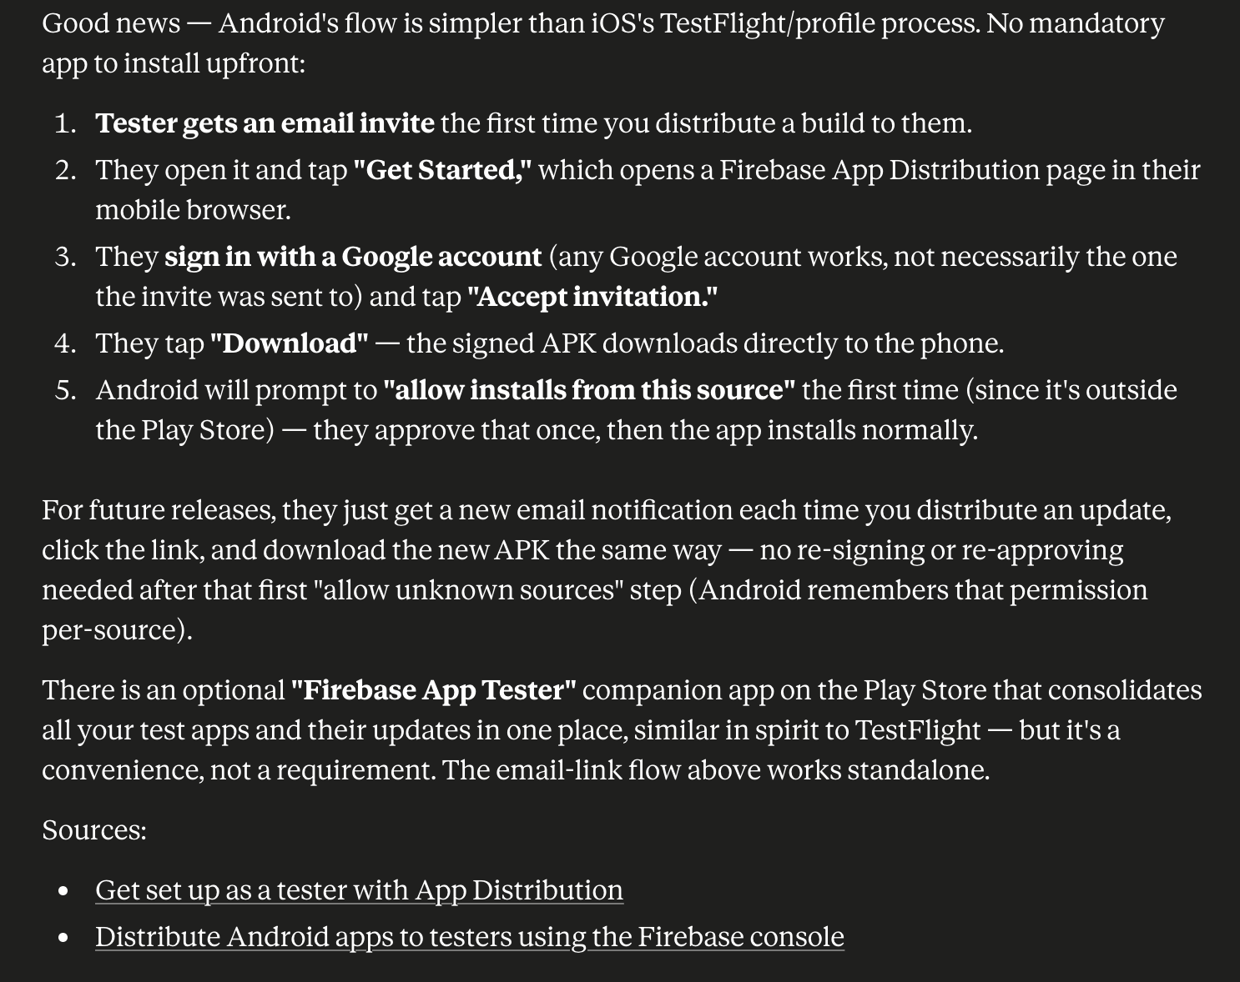

MAKE SURE TO UPDATE VERSIONS!
